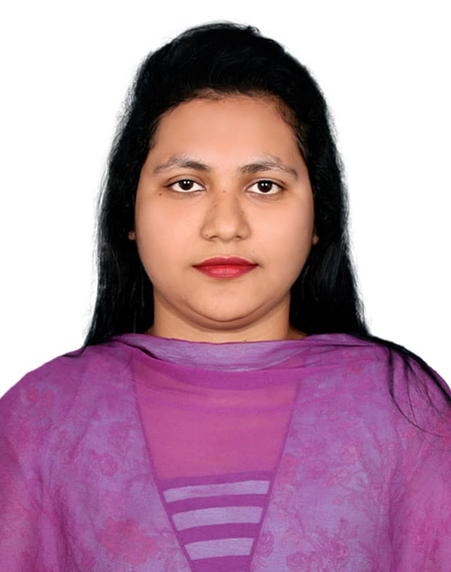
Sharmin

 Vatara, Dhaka  Cell: 01865684826 sharmin.idb.info@gmail.com

CAREER OBJECTIVE:
I can utilize my skill effectively and provide best performance to accomplish the goal of the organization with utmost care as well as to achieve the professional skill expertise for the betterment of the organization. To achieve this aim, determined to offer honesty, efficiency and sincerity to the optimum level.

Education | Master of Business Administration (MBA)  Northern University Bangladesh  Major: Marketing  CGPA: 3.68  Passing Year 2019  Bachelor Of Business Administration (BBA)  Northern University Bangladesh  Major: Finance  CGPA: 3.40  Passing Year 2016  Higher Secondary Certificate Examination (H.S.C)  Shakhipur Residential Women’s College  Humanities  CGPA: 5.00  Passing year 2012  Secondary School Certificate Examination (S.S.C)  Adarsha Girl’s High school  Science  CGPA: 3.94  Passing year 2010

Technology | MS-OFFICE, ORACLE APEX, MYSQL, HTML, CSS, BOOTSTRAP, JAVASCRIPT, PHP LARAVEL With Good Typing Skill.

Training | I have been completed Database Design & Development at ISDB-BISEW IT Scholarship Programme

Experience |  | PHP Project: https://github.com/SharminShaan/blog  HTML Project: https://github.com/SharminShaan/html_project  Oracle Apex Project Link:  Front Page : https://apex.oracle.com/pls/apex/r/shaan/ecommerce/products1  Backend: https://apex.oracle.com/pls/apex/r/shaan/ecommerce/purchase-report?session=132051813840426  User: admin Password: admin123

Personal Information
  Father’s Name | Main Uddin
  Mother’s Name | Ferdousi Begum
  Permanent Address | Batajor Road, Jeilkhana Mour, Sakhipur, Tangail
  Date of Birth | 10/09/1994
  Marital Status | Married
  Religion | Islam
  Blood group | AB⁺
  Nationality | Bangladeshi (By Birth)
  NID | 6440231220

.........................
SHARMIN

